SET-03
5.Write a Pandas program to create a bar plot of the trading volume of Alphabet Inc.
stock between two specific dates.
Code:
import pandas as pd
import matplotlib.pyplot as plt
df = pd.read_csv("Alphabet.csv")
df["Date"] = pd.to_datetime(df["Date"])
data = df[(df["Date"] >= "2024-01-01") &
(df["Date"] <= "2024-01-05")]
plt.bar(data["Date"].dt.strftime("%Y-%m-%d"), data["Volume"])
plt.title("Trading Volume")
plt.xlabel("Date")
plt.ylabel("Volume")
plt.xticks(rotation=45)
plt.show()
Output:
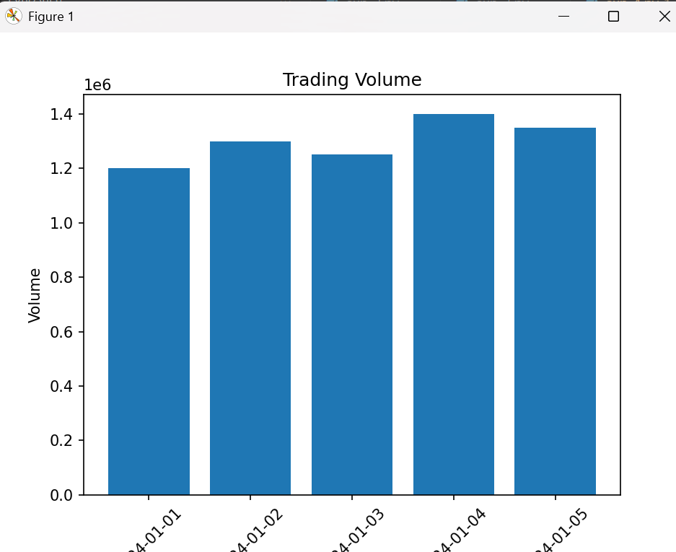
6.Write a Pandas program to create a scatter plot of the trading volume/stock prices of
Alphabet Inc. stock between two specific dates.
Code:
import pandas as pd
import matplotlib.pyplot as plt
df = pd.read_csv("Alphabet.csv")
df["Date"] = pd.to_datetime(df["Date"])
data = df[(df["Date"] >= "2024-01-01") &
(df["Date"] <= "2024-01-05")]
plt.scatter(data["Volume"], data["Close"])
plt.title("Trading Volume vs Closing Price")
plt.xlabel("Volume")
plt.ylabel("Closing Price")
plt.grid(True)
plt.show()
Output:
